**Remind Me!!**

**Introduction:** This is an android app of different applications with voice alert systems, which is an integration of google maps, voice Alert. One is to provide an alert in a journey and other is to save the list of grocery items and date on which he has to buy and provide alert on that day. It also has parent- child accounts where parents can monitor all the child activities.

**Project Goal and Objectives (revised):**

**Main Goal:** The overall goal is to provide a voice alert system, which reminds them for almost all day to day activities.

**Motivation:** Sometimes a person can have 2 or more meetings in a day or cannot remember what he has to buy (groceries), so this app acts as a personal assistant which reminds him about the plans/warns him if he is running out of time or for the items he has to buy.

**Significance:**

* It is an android application which can be used in all the android mobiles.
* Acts as a personal assistant by tracking your location.
* It is easy to remember all the important things and using user set reminder for all the activities that needs to be done.
* Parents has the ability to monitor and alert the child.

**III. Project Background and Related Work:**

The roots of this project comes from the reminder app we have in our mobile which can only reminds you by text.

The similarities of the proposed project is the basic work of the application. I.e. it acts like a reminder

The dissimilarities of the proposed project include providing users an interactive system that enables them to post their daily activities or journey plan that needs alert and also gets directions to the places. As a simple reminder just alerts using the ringtone, this system alerts user by his recorded voice, and so if a user is driving a car he doesn’t need to check his mobile for what the notification is.

**IV. Proposed System**

**1) Requirement Specification**

**System features:**

This app has different tabs

Login: A person has to login in to his account.

Register: Person has to register, if he is using the app for the 1st time.

*How to use tab:* Provides information about how to use this application.

*Exit:* When he completes his daily routine he can press this tab to stop the application

After a person logins, it has 2 tabs

1. Journey tab
2. shopping tab

**In journey/Appointment tab:**

*Start:* User needs to press his tab when he wants to start his journey.

*Exit:* When he completes his daily routine he can press this tab to stop the application.

**In shopping tab:**

*List:* list of items he has to buy in different places like Walmart, Costco.

*Date:* it’s the date on which he wants to buy groceries

**How this works?**

**Journey tab:**

For example if the user wants to go to St. Louis from Kansas city for some project meeting, and he needs to halt in lee summit and emporia as he needs to meet some other persons regarding their project.

So user enters the following details

*Name of the plan:* Meeting at St. Louis

*Source location:* Kansas City

*Destination location:* St. Louis

*Date of journey:* 22/02/2015

*Expected arrival time to destination:* 6:00 pm

Record voice for reminder

*Number of halts:* 2

User also enters the following details:

*Halt station:* Lee Summit

*Expected arrival time:* 2:00 pm

*Expected departure time:* 3:00 pm

User required voice reminder

Needs to enter same for the second halt (emporia).

After providing all the details the user needs to activate the application before starting his journey.

Application alerts the user in the following cases:

1. If user doesn’t reach lee summit by 2:00 pm from Kansas City.
2. If user doesn’t leave lee summit by 3:00 pm.
3. It also triggers a voice recorded by the user if user is near the location, to remind him that he has some work at that location before reaching the destination.

User can also edit the planning following cases like

1. User can delete the halt if he has a change in plan or
2. User can also delete the whole plan if the meeting was cancelled or
3. User can change that if the meeting was postponed.

**Shopping tab:**

The user enters the list of items he needs to buy and sets the date on which he has to buy it. On the specified date the user gets an alert saying he has to buy items.

*List:* the items user needs to buy

*Date:* date on which he has to buy

*Map:* Directions to the place where he has to buy items

**Architecture:**

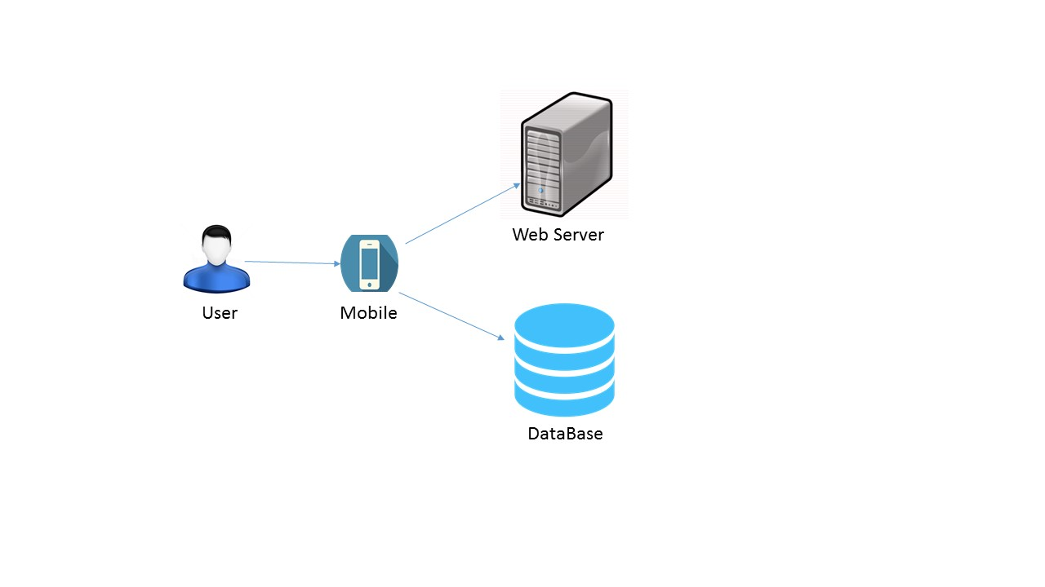

**Class diagrams:**

**For Appointment/journey tab:**

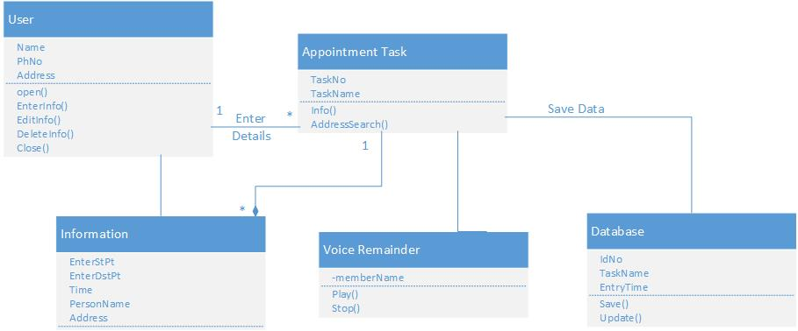

**For shopping tab:**

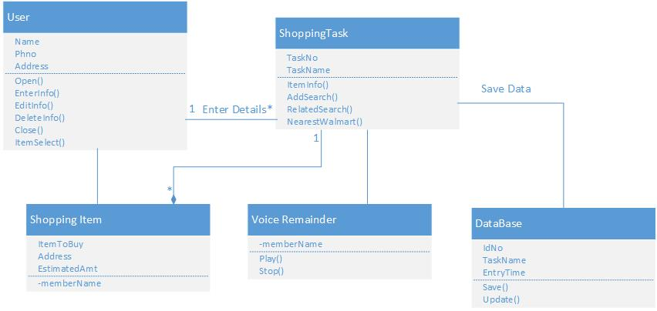

**Activity diagram:**

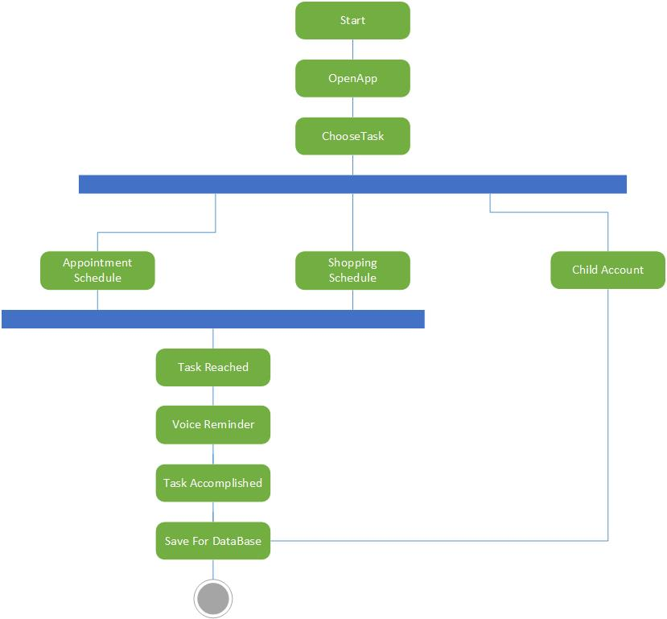

**Sequence diagrams:**

**For Journey tab:**

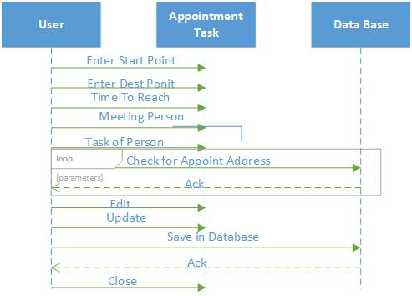

**For shopping tab:**

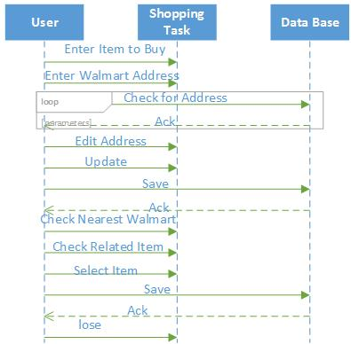

**Existing Service`s:**

1. Name: Google Maps API.

Description: Used to show directions for the journey and stores to buy items for shopping

URL: <https://developers.google.com/maps/documentation/javascript/tutorial>

1. Name: Google text to speech API

Description: Used to convert the text given by the user to voice

URL:  <http://weston.ruter.net/2009/12/12/google-tts/>

1. Name: Walmart API

Description: used to collect data from Walmart

URL:http://api.walmartlabs.com/v1/search?apiKey={apiKey}&lsPublisherId={Your LinkShare Publisher Id}&query=ipod&categoryId=3944&sort=bestseller&responseGroup=full

**Development side:**

* Front End       :  Eclipse Galileo
* Tool                  :  Android SDK 2.1
* Back End        :  SQLite Manager

**Technologies used:**

**For Frontend design:**

Eclipse Galileo, Android Studio, JQuery, Twitter Bootstrap, HTML5, CSS

**Back End:**

SQLite Manager

**Database:**

Microsoft SQL Server 2008.

**Scrum do Link:**

https://www.scrumdo.com/projects/project/remind-me/iteration/121772/board

**Team Members:**

Prashanth Venna (class id 51)

Mallika Palreddy (class id 37)

Venkata Purnesh Gaddam (class id 16)

Mehaboob Gori (class id 54)

**References:**

<http://www.programmableweb.com/api/google-maps>

<http://www.programmableweb.com/api/walmart-open>

<http://www.programmableweb.com/api/text-to-speech>

<http://s5884.com/itp/2014/03/13/making-a-reminder-app-with-android-sdk/>

<https://developer.android.com/training/basics/firstapp/creating-project.html>

<http://stackoverflow.com/questions/636689/difference-between-frontend-backend-and-middleware-in-web-development>

<http://cxf.apache.org/docs/dynamic-clients.html>

<http://en.wikipedia.org/wiki/List_of_features_in_Android>

<https://www.gazelle.com/thehorn/2014/02/10/the-android-operating-system-10-unique-features/>

<https://play.google.com/store/apps?hl=en>

http://www.androidcentral.com/best-shopping-apps-android